Bilal Afreedi
IT 370
Intro to Analytics
Tableau

Creating Groups in Your Data
What are groups in Tableau?
When you have a detailed list of items and want to organize them together into a single group, you can create groups instead of creating a new field in the database.
- A group lets you combine several members of a single dimension into a single data point or category type, creating a new dimension field.
- The group can then be used repeatedly in visualizations.
- Groups are represented by a paperclip
Group use Scenarios:
Ad hoc (in the moment) analysis
- Isolating a problem: an airline has a spike in lost baggage escalations. Grouping the destinations that are most affected allows the company to discover what they have in common, such as shared stopover location that is using outdated baggage scanners.
“What if” scenarios
- Where to invest: a retail company needs to determine what will bring the most profit for future investments. Grouping a long list of products into categories such as technology, healthcare, clothing, furniture products etc. allows the company to make informed decisions based upon overall profit.
Creating data errors
- Avoid data duplication (typos): grouping CA, Calif., and California into one data point helps avoid duplication in the data.
Reuse
- A single solution to answer multiple needs: a university is analyzing average test scores by categories of majors. English and History are combined into a group called Liberal Arts Majors, while Biology and Physics are grouped as Science Majors, and so on.
- After the groups have been created, they are able to be used in several other ways. In this example, students can compare hours of electives between different majors.

Methods for creating groups:
- Create a group based on a field in the data pane
- Create a group based on labels in the view
- Create a group based on marks in the view
Each of these methods create a new dimensional field that can be used in you visualization, however the behavior is different for each creation method.
In the data pane
- Long lists are more easily grouped in the data pane than from within the view.
- This method opens a dialog box that gives you more options, such as scrolling to find members or performing searches to find a specific field.
- Grouping from the data pane allows you to select members that are not visible in the view.
Labels in the view
- When creating a group using labels from within the view, the changes show in the view immediately.
Marks in the view
- When creating a group using marks from within the view, the changes show in the view immediately, and the group is also applied to Color on the Marks card.

Creating Hierarchies in Your Data
What is a hierarchy in Tableau?
In tableau, a hierarchy is an arrangement of data fields in a hierarchal format with an “above” and “below” structure.
- When a hierarchy exists in your data, you can see how fields relate to one another in tiers, view the structure of it, and access the data in the shelf and within the visualization.
Date hierarchies
For relational data sources, dates and times are automatically placed in the dimensions area of the Data pane and are identified by the date or date-time icon, and can be drilled up and down as a hierarchy.
Date fields can consist of the following:
- Year
- Quarter
- Month
- Day
- Time
Creating hierarchies
Any type of data can be organized into a hierarchy.
- A hierarchy can contain as few as two fields, or it can be deep with many fields, depending upon what data is needed for your analysis.
When we create hierarchies in Tableau, we preserve the list order for reuse in visualizations.
Examples of hierarchies:
Generations in a family tree can be categorized as follows:
- Great-Great Grandparents
- Great-Grandparents
- Grandparents
- Parents
- Person
Geographical Locations:
- Continent
- Nation
- Region
- Division
- State
- County
- City
- District

Understanding Filtering in Tableau
Filtering data makes it easier to focus on relevant information in a large dataset or table of data.
- Filtering does not remove or modify data; it just changes the data that appears in your view.
Types of filters
Extract Filters
When you connect to data, you can choose to extract it, saving a snapshot of how it looks in your workbook and ultimately reducing the number of times Tableau queries the data source.
- As part of this process, you can filter out data that isn’t relevant to your analysis.
- For example, you are querying a data source that has data for the last 20 years, but you only want the last 5 years of data. Extract filters would be ideal in this case.
Data source filters
Data source filters reduce the amount of data being fed into tableau and restrict what data the viewer sees.
- With certain access rights, the viewer can view all of the underlying data in a data source.
- If sensitive data hasn’t been excluded from the data source, use data source filters to filter it out.
- For systems that rely heavily on partitions or indexing, data source filters may yield tremendous control over the performance of queries issued by tableau.
Context filters
All filters in tableau are computed differently. If you want one filter to be applied before other filters, make it a context filter so it will be processed first.
- For example, if you have two dimension filters, one on Region and another top 10 on products, both filters will apply to the entire data set.
  - If you want to see the top 10 products in each region, set the Region filter as the context filter.
Dimension filters
Dimensions contain discrete categorical data, so filtering this type of field generally involves selecting the values to include or exclude.
- For example, use a dimension filter to show products that have low sales in specific regions.
Measure filters
Measures contain quantitative data, so filtering this type of field generally involves selecting a range of values that you want to include.
- For example, show only products that have sales greater than 10,000
Date filters
Date filters allow you to filter data by range of dates, relative dates, or exact dates.
- For example, show products that have been ordered starting January 2017.
Table calculation filters
These filters are applied after the view has been produced.
- So if you want to filter the view without filtering the underlying data, table calculation filters are the way to go.

Filtering order of operations
When you use multiple filters on your data, the filters get applied in a very specific order.
Tableau executes filters in the following order.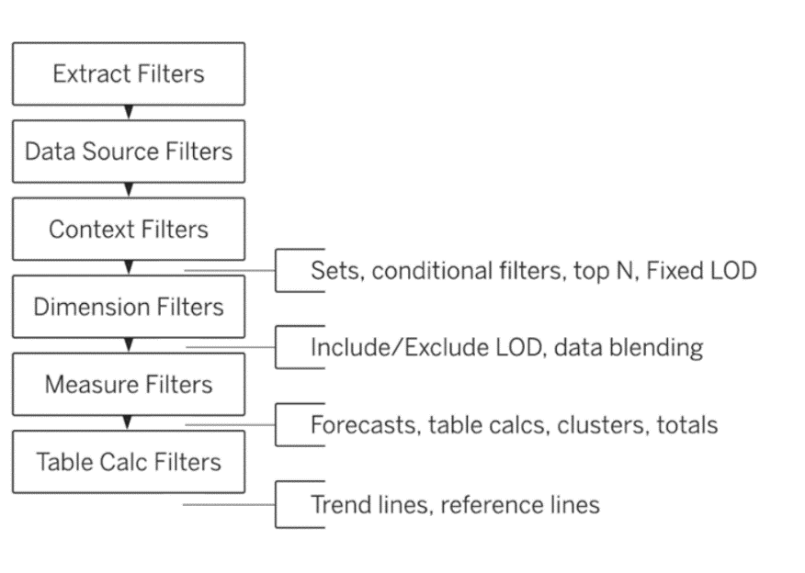

Filtering Your Data
Create a dimension filter
A dimension filter restricts categorical data in your view.
- The members present in a dimension can be included or excluded using this filter
The easiest and the most basic way of filtering dimension data on a view is to include or exclude data points, also referred to as marks, from your view.
One way of creating a dimension filter is to drag the dimension field from the Data pane to the Filters shelf. When you do this, the Filter dialog box appears which allows you to specify the type of filter you want to create.
Edit Filter dialog box
General tab
Use the General tab to select the values you want to include or exclude.
- You can select All or None, or even choose to exclude some values.
- If the list is very long, you can also use search.
- Additionally, you can select from the list, create your own custom list, or choose to use all items.
Condition Filter tab
Use a Condition filter to specify conditions for you filters.
- For example, you can create a filter on Sub-Category that meets the condition of Sales greater than 250,000.
- You can also use a formula to specify a condition in tableau desktop.
Top Filter tab
For a very large set of data, you might want to filter that shows the top or bottom items, like the Top 10 items sold.
Or, in a view that shows products sales, you can decide to only show the top 10 products by Sales. Rather than having to define a specific range of Sales (e.g., greater than $10,000), you can define a limit (top 10) that is relative to the other member in the field (products).
- You can also use a formula to specify a condition in tableau desktop.
Wildcard Filter tab
(Tableau desktop only)
A wildcard filter allows you to specify a value – a number, letter, or word, for example – for items you want to include or exclude.
- For example, when filtering on customers that have names starting with B, you can specify a wildcard filter that starts with B*.
Did you know?
Filters can be created on fields that are not in the view
- To create a filter on a field, the field does not have to be in the view.
- You can create a filter on any field in the Data pane.
There is a quick method for creating a filter in Tableau desktop
- You can create a quick filter by right clicking the field in the Data Pane and selecting Show Filter.
- The field will automatically appear in the Filters shelf and the view.
- You cannot do this in tableau cloud.
Filters can be created in one worksheet and be reused across worksheets
By default, a filter only applies to the worksheet that it is created in.
- But you can change that by right clicking the filter in the Filters shelf and selecting Apply to Worksheets.
There is a difference between the ‘Use all’ and ‘Select from’ list options
‘Use all’ allows you to specify that all members are used as an input to the filter.
- This means that if the list of members change, the list will update to reflect the changes.
‘Select from list’ limits the filter to the members you select initially.

Customize the appearance and interaction of a dimension filter
There is a difference between Remove filter and Hide Card options
- The Remove Filter option removes the filter from the Filters shelf.
- Hide Card/Filter only removes the filter card from the view.
“All Values in Context” is only available for context filters
- You see this option only when one of the filters in the view is a context filter.
- Select this option on a different filter to only display values that pass through the context filter.
“All Values in Hierarchy” displays only for hierarchal fields
- When you create a filter from a hierarchal field, this option is selected by default.
- Filter values are displayed based on relevance of the parent/child relationships in the hierarchy.
There is a reason why you see a red ‘x’ on the Show All Values button
- Whenever data is excluded in the filter, the small red ‘x’ appears on the Show All Values button.
The Show Apply button does not work for single value list filter
- This option is only available in multiple value lists and dropdowns

Create and customize measure filters
Measures contain quantitative data, so filtering this type of field generally involves selecting a range of values that you want to include and showing only the values that meet your filter criteria.
Examples:
- Filter on quantity
- Filter on discount
Four types of measure filters:
Range of values
- Select the range of values option to specify the minimum and maximum values of the range to include in the view.
- The values you specify are included in the range
At least
- Select the At Least option to include all values that are greater than or equal to a specified minimum value.
- This type of filter is useful when the data changes often and specifying an upper limit may not be possible.
At Most
- Select the At Most option to include all values that are less than or equal to a specified maximum value.
- This type of filter is useful when the data changes often and specifying a lower limit may not be possible
Special
- Select the Special option to filter on Null values. You can choose to include null values, non-null values, or all values

Create date filters
Use a data filter to filter data on a specific date or time criteria.
- Tableau allows you to create filters on continuous date values or discrete date parts.
Date filter examples:
- Discrete date part filter
- Continuous date value filter
Drag a date field from the Data pan to the Filters shelf. Dialog box appears.
- You can recognize a date field by the small calendar icon.
- You can filter by discrete date parts, such as years, quarters, months, or by a continuous date range.
- All the options for filtering on date parts have a blue data-type icon.
- The date-range options have a green data-type icon.
- In the dialog box, you can select whether you want to filter on a relative date; filter between a range of dates; or select discrete dates or individual dates to filter from the view.
Sometimes you may want to filter to include specific dates, maybe looking for sales data for specific years or even for certain quarters.
- This type of filter is called a date part filter because you are defining discrete values instead of a range.
Continuous date filters allow you to filter data on a range of dates.

Sorting Your Data
Overview of sorting in tableau
Two sorting methods:
- Computed
  - Computed sorts organize the data by applying rules and are dynamic
- Manual

Sort data using computed and manual sorts
Tableau also allows you to manually specify and order so that even if the data changes, the order of the sort you defined is maintained.
Different types of sorts from dialog box:
Data source order
- Lets you sort based on how the data is sorted in the data source.
- Generally, for relational data sources, this tends to be natural sort order.
  - Natural sort order is an alphabetic sort where multii-digit numbers are treated as a single character.
  - For example, natural sorting puts 2 before 19 because 2 is less than 19, whereas alphabetic sorting puts 19 before 2 because 1 is less than 2.
Alphabetic
- Lets you sort data alphabetically,
- This sort case is sensitive, sorts uppercase before lowercase letters and treats digit individually.
Field
- Lets you select the field whose value will be used to determine the sort order
- This field does not need to be used in the visualization
- You can also select an aggregation for the sorting field.
  - The aggregation options available depend on the field type.
Manual
- Lets you select a value and move it to the desired position, either by dragging it in the list or using the arrows to the right
Nested
- Lets you select the field whose values will be used to determine the nested sort order.
- The field does not need to be used in the visualization.
- You can also select an aggregation for the sorting field
  - The aggregation options available depend on the field type
Did you know?
Sorting can be cleared by using a single button clock
- When a sort is applied to any field, an icon appears next to it to indicate where the sort is applied.
- You can easily remove a sort on a specific field, by right clicking to open the menu and selecting Clear Sort
Common sorting options can be cycled through by clicking
- When sorting from an axis, header or field label, you can click though the various options.
- One click sorts descending, two clicks sorts ascending, and three clicks clear the sort.
Sorting can be disabled
- As an author you can disable the sort icons in published content.
Sorting options vary based on authoring or editing mode

Sort multiple-pane views using nested sorts
When the values to be sorted occur in multiple panes, there are two ways to sort: nested and non-nested (or comparative)
Nested sort
- A nested sort considers each pane independently and sorts the rows per pane
- Nested sorts are correct within the context of the pane, but don’t convey the aggregated information about how the values compare overall.
- Sorting from an axis gives a nested sort by default, or you can use the Sort menu, select Nested under Sort By, and select the field on which you want to sort.
Non-nested sort
- A non-nested sort considers the values across panes and will have the same order of values per pane.
- This type of sort is most useful when you want a comparison across all items in a view.
- Non-nested sorts may look incorrect in a single pane, but consistently convey how the aggregated values compare overall.

Using Sets to Highlight Data
Sets in Tableau
Sets are custom fields that define a subset of data.
- Sets are useful for viewing and highlighting data that meet specific criteria.
- For instance, sets can help you identify customers with sales exceeding a certain threshold or cities with high school graduation rates above or below the national average.
During analysis, you can use sets to:
- View or highlight data that meets a specific computed condition, for example, a set that contains only customers with sales exceeding a certain threshold.
- Monitor key data points, for example, high- or low – performing sales regions.
- Combine multiple, specific fields that you want to view together, for example, items that are top sellers but are also highly discounted.
Additional use cases for sets in data analysis:
- Analyze how members of a set contribute to the total
  - You may have questions such as, “How do the members in a set contribute to the overall total?”
  - For example, an essential oils company is seeking to create a new formulation of blended oils for anti-aging. They have over 25 oils that are specific to anti-aging from which to choose.
  - They create a set in Tableau that includes top selling anti-aging essential oils. They compare that set to all of their available oils to determine which formulation is most likely to bring the greatest profit for the company.
- Compare subsets of data or cohorts
  - Another common use of sets is to compare subsets of data or cohorts
  - For example, you may wonder how many customers who made purchases last year also made purchases this year. Or if a customer purchased a specific product, which other products did they buy? You can answer these types of questions by creating sets for each cohort and combining them for additional analysis.

Types of sets:
Fixed
- The members of a fixed set do not change, even if the underlying data changes.
- The only way you can change a fixed set is if you edit the set and either add or delete dimension members.
- A fixed set can be based on a single dimension or multiple dimensions.
Dynamic
- The members of a dynamic set change when the underlying data changes
- Dynamic sets can only be based on a single dimension
- Dynamic sets are useful when you want to analyze data that changes frequently

Create sets
Fixed sets are most useful when you want to create a subset of data by picking specific members of a dimension.
You can create a fixed set by selecting marks in a view or using the Create Set option for a dimension from the Data pane.
Creating dynamic sets
If you want a set to update its members when the underlying data changes, you need to use a dynamic set.

In Tableau, you can combine two sets to compare the members. When you combine sets, you create a new set containing either the combination of all members, just the members that exist in both, or members that exist in one set but not the other.
Combining sets allows you to answer complex questions and compare cohorts of your data. For example, to determine the percentage of customers who purchased both last year and this year, you can combine two sets containing the customers from each year and return only the customers that exist in both sets.
To combine two sets, they must be based on the same dimensions. That is, you can combine a set containing the top customers with another set containing the customers that purchased last year. However, you cannot combine the top customers set with a top products set.

Did You Know?
What’s the difference between a set and a group in Tableau?
Grouping in tableau is one dimensional, used to create a higher-level category by using lower-level category members.
Creating a set in Tableau is putting multiple values in a single set depending on a condition or by manually picking them.
Groups | Sets
Static; must be manually changed | Can be static or dynamic
No limit to the number of groups | Binary (In/Out)
Processed as dimension filters | Processed before dimension filters

What’s the difference between using a filter or a set in a view?
Filters only apply to the current worksheet. Sets can be reused throughout the workbook. Since sets become part of the metadata, any workbook connected through that saved data source (or .tds file) can also utilize its functionality. Using sets maintains consistency and saves time. They can also be combined to create an even more specific subset of the data.

Use sets in analysis
You can use sets with other features of tableau to enhance an analysis.
Sets can be used like any other field in a view.
- Once you have created the set, you can drag it into the view to identify al the dimension members that are in and out of the set.
Use a set in a view in the following ways:
To encode marks
- You can encode marks of a view by dragging the set to Color on the Marks card.
In calculated fields
- Sets can be used in calculated fields just like dimensions or measures.
- You can treat dimension members differently based on whether or not they are in a set.
Using sets as filters
- Sets can also be used as a filter by dragging the set to the Filters shelf.
- Any set you create can be used across all worksheets in a workbook. Sets are binary, so when you add them as a filter, you will only have the option to choose whether the marks on the view are in or out of the set.
Set control
- To give your audience the ability to quickly modify members of a set, you can also display a set control.
- A set control is a worksheet card that is very similar to a parameter control or filter card.
- You can only display a set control for dynamic sets = not fixed sets.

Tableau’s order of operations with sets
Sets are higher than dimension filters in order of operations

Working with Dates to Visualize Time-Based Data
What are continuous and discrete fields?
Continuous fields, such as dates, prices, and wind speeds, contain values that can fall anywhere on an x axis
Discrete fields, such as country names, types of office furniture, and the components of dates, such as days and months, contain values that can only fall into specific categories.

Work with date fields in your views
Tableau provides two different ways to visualize date fields: as continuous date values or discrete date parts, and which you use in a view affects how your data is represented.
- For example, when date fields are added to views as continuous date values, such as 1/1/2020, 1/2/2020, and so on, they show data across time along as axis.
- And when date fields are added to views as discrete date parts, such as month, they aggregate data into categories such as January, February, and so on.

Continuous date values
Also called date values, represent the chronological progression of time.
- Appear as green fields when places on a shelf.
When you add a date value to a view, tableau creates a continuous timeline along an axis.

Discrete date parts
Also called date parts, are distinct units of time contained in your date
- Examples of date parts include Month, Week Number (such as week 1, week 2), and Weekday.
- Appear as blue fields when placed on a shelf
When you add a date part to a view, tableau creates headers for the units of the date parts, rather than creating a timeline on an axis.

Configure continuous date values and discrete date parts
When to use a continuous date value
Use continuous date values to visualize how your date changes over a range of time, such as over the course of a month, a year, or several years.

When to use discrete date parts
Use discrete date parts when you want to compare a measure for specific units of time, such as months, to each other.
- For example, you might want to compare sales for every June to sales in every December to identify recurring or seasonal trends
It’s important to know that choosing Discrete or Continuous from the date field drop-down menu will not change whether a date field is used as a discrete date part or a continuous date value in the view.
- Choosing these options determines only whether the views is displayed with headers (discrete) or an axis (continuous).

Change date field and calendar defaults
When a date field in brought into a view, it defaults to a discrete part at the highest level.

Changin a date field to a continuous date value
To change a date field from a discrete date part to a continuous date value, in the Data pane:
- Click the field’s drop-down menu
- Click Convert to Continuous

Changin a data source to an ISO-8601 week-based calendar
Tableau uses the Gregorian calendar by default.
However, if your organization uses a week-based calendar, with Monday as the first day of the week, you can specify the ISO-8601 calendar as your preference for your data source.
- This change will apply to all worksheets using the data source, affecting date fields, context menus, filters, and so on.
To change a date source to use the ISO-8601 calendar as the default, follow these steps:
- Click the Data menu
- Point to the desired data source
- Click Date Properties
- In the Date Properties dialog box, click the Default calendar down arrow
- Select ISO-8601 Week-Based
- Click OK
Changing a date field in a view to an ISO-8601 week-based calendar
If you want a specific date filed in a view to us the ISO-8601 calendar:
- In the view, click the date field down arrow
- Click ISO-8601 Week-Based

Use continuous date values and discrete date parts
Expand a date part to add detail to your view
Expanding a date part in a view provides additional levels of detail to the view, such as expanding Year, to Quarter, Month, and Day.
To expand a date part:
- Click the date part plus sign

Move date parts to enable different analysis
When we’re looking at discrete date parts, the expanded date parts on Columns or Rows are displayed as multiple instances of the date field, one for each date part.
- This allows us to quickly remove date parts
In tableau we can also adjust the way we view the data by shuffling the date parts on Columns and Rows.

Show change over a continuous range of time
To revise the view so it shows change, such as in sales over a continuous range of time, you need to use a date field in the view as a continuous date value.

Expand a continuous date value to add detail to a view
Similar to discrete date parts, we can expand the level of detail for date values.

Dates can be used in different ways by switching between discrete date parts and continuous date values or by bringing the same filed into the view in multiple places, and even at different levels of detail.

On Columns or Rows, when expanding a date field that is a continuous date value, you can include one levels of detail for the field in the view.
Do more analysis with color and filters
You can change views in other ways, enabling additional analysis, such as bringing date fields to the Marks card and the Filters shelf.
For example, adding a discrete date part Year to the Color Marks makes it easy to focus on each year of data while still seeing the annual trend.

Filter on a date part or date value
Changing a field between a discrete date part and continuous date value also changes how it behaves on the Filters shelf.

Create Custom Date Fields and Hierarchies
Create custom date fields
You can create custom date fields in tableau, using discrete dates part and continuous date values, and use them in views so they provide you users the exact experience you want for them everytime.

Create a custom continuous date value
Custom dates can be created as either discrete date parts or continuous date values.
To create a custom continuous date value:
- Click down arrow on a Date field from Data pane
- Point to Creae
- Click Custom Date
- Proceed in dialog box with date value checked

Create custom discrete date part
Follow same steps as right above
Custom date fields don’t have plus sign for hierarchies

Create a custom date hierarchy
You can create a custom date hierarchy from discrete date parts.
To create a custom date hierarchy you first need to create another related custom discrete date part.
Drag different custom discrete date fields onto each other to create hierarchies, like dragging Discrete Date Months onto Discrete Date Years.
- This will bring up a Create Hierarchy dialog box to create a name for the hierarchy
A custom hierarchy is a good way to customize the data in a view, either for you own analysis or for other users you share it with.
- It can also help with the performance of your view. (regarding sending of queries)

Comparing Multiple Measures in Views
What are Measure Values and Measure Names?
The Data pan always contains several fields that do not exist in you original data source, two of these are Measure Vales and Measure Names.
- Tableau automatically creates these two fields for each data source when you connect it to a workbook.
- The Measure Values and Measure Names fields serve as containers for the measures in the Data pane
The Measure Values field is a measure that contains the values of the measures.
The Measure Names field is a dimension that contains the names of the measures.
- Note that it does not include measures, such as Latitude, which do not aggregate the same way as other measures.

Create text tables with multiple measures
Text tables, also called crosstabs, enable you to compare multiple measures in the same view, using a layout like spreadsheets
- Like spreadsheets, text tables can be daunting to read and difficult to glean trends from, especially when they contain substantial amounts of data.
Text tables do, however, have their place, especially in finance.
- They contain up to fifty measures on Rows and sixteen on Columns, but the more measures there are the more difficult it can be to analyze the data.
Measures in text tables can have different units, such as dollars of Sales and the number of Orders
- Measures in a text table use the text mark.
You can manually add Measure Values and Measure Names to views, just like other fields.

When you add Measure Values to a view, tableau creates a Measure Values card that lists the measures in the data source with their default aggregations, such as sum.
- You can change the aggregation for measure in the card and remove individual measures from the view by dragging them out of the Measuer Values card.
When you add Measure Names to a view, the measure names appear in the view as row or column headers, depending on whether you add it to Rows or Columns.

With Measure Values or Measure Names in a view, you can act on all measures in the view simultaneously, such as filtering on Measure names, or changing the color of Measure Values

Make views with multiple measures on the same axis
Views with multiple measures on the same axis enable you to glance at the views and easily compare the measures, whether it’s a bar or other type of chart.
- You can add fifty measures on the same axis, but the more you ad, the harder it can be to analyze the data.
It is best if measures that share an axis have the same unit of measurement, such as dollars of Sales, Cost, and Profit.
- Having different units on the same axis can make the view difficult to understand.
- Measures that share the same axis use the same type of mark, such as bar.

Build dual and combined axis charts
Dual axis charts have two axes for the measures and one for the dimensions.
Dual axis charts are useful for showing how two measures compare to each other.
- You can show measures with the same of different mark types, such as area and line.
- The measures can have different units, such as dollars of Sales and number of Orders.
Dual axis charts can also show two measures with different number formats.

Using Scatter Plots To Show Relationships Between Measures
Create and use scatter plots to identify relationships
A scatter plot enables you to display a lot of data at once, yet quickly spot clusters, correlations, trends, and outliers in the date.

Evaluating date clusters
Sometimes the marks in a scatter plot form well-defined groups, called clusters.
- Determining why clusters exist can be difficult, but crucial to the analysis of your data set.

Identifying correlations and trends
A correlation is a statistical relationship between values.
When you view a scatter plot, look for these types of correlations:
- Positive correlation
  - When measures have a positive linear correlation, high or low values in the measures show similar trends
  - For example, comparing a sales increase with a profit increase and see a positive correlation
  - Note: when you find a correlation between two measures, you can’t assume with certainty that one event causes the other without additional data and observation.
    - Correlation between measures means a relationship exists, but causation indicates one actually causes a change in the other.
- Negative correlation
  - When measures have a negative linear correlation, high or low values in the measures show opposing trends.
  - For example, maybe you’re comparing a price increase with a sales decrease and see a negative correlation.
  - Note: measures can have nonlinear correlation
- No correlation
  - When measures have no correlation, values in the measures show no relationship.
  - For example, maybe you’re comparing the size of headphones with the price of headphones and see no correlation.

Use correlations and trends to analyze data
You use scatter plots to answer questions about the correlation between types of measures, such as whether there is a correlation between the wait time between eruptions and eruption duration at old faithful.

Identifying Outliers
Outliers are values that appear to diverge from a trend
- A scatter plot is an effective chart type for identifying outliers

Managing outliers
Outliers can be interesting and are usually worth investigating so you know how to interpret them
- Are they rare exceptions that can be disregarded?
- Or an indication of something to examine more closely?
- Or maybe they’re simply errors in recording or transcription?
- To be sure, examine the underlying data to make your determination.

Excluding an outlier from a view
If you know an outlier is a rare exception that can be disregarded, and you want to exclude it from a view, follow these steps:
- Press Ctrl and select the outliers
- On the toot tip that appears, click Exclude

Adding an annotation to an outlier
If you want to add information about an outlier to make the view more informative, you can add annotation. To add an annotation:
- Right-click on the outlier
- Point to Annotate
- Click Mark
- Use the Edit Annotation dialog box to create your annotation
- Click OK

Creating Spreadsheet-like Views Using Text tables
Create and work with text tables
Text tables display data in rows and columns, similarly to spreadsheets.
- They require one or more dimensions and one or more measures, and they use the Text mark type
Text tables are one of the most common representations of data. While they’re not highly visual and are, therefore, not ideal for showing trends and outliers, they’re useful for displaying specific values.
They can also serve as great reference tools, such as providing you with a way to check your data for accuracy as you build more visual views.
Text tables can also be used for drilling down from summary visualizations to more detailed information, such as when a text table is used as a filter in part of a dashboard.
People in certain roles, such as accounting and finance, commonly use text tables as a report format.
- If you’re creating a view for such an audience, you may need to present the data in a text table.
However, you might also want to consider more visual table-based views, such as highlight tables
- Highlight tables provide the format the audience wants, but they also include visual components that make the view easier to interpret.

Create a text table to reference and analyze data
You can create a text table from an existing view or from scratch.

Add totals and change aggregation
When analyzing data, users often refer to text tables.
- It can be helpful to include aggregations in the view such as totals, subtotals, or averages of columns and rows to provide users with high level information
- You can use the Analysis menu to add these aggregations to a text table.

Using a Highlight Table to Show Specific Values
The purpose of a highlight table
Sometimes, we need to represent the specific values in our data alongside our visualization.
A highlight table is useful for showing data values while also revealing key values – such as the highest or lowest – which may also reveal patterns in the data.

Do I need a highlight table?
When you are deciding whether a highlight table is a good chart type for your data source and the analysis you want to do, consider the following questions:
- Do you need to represent specific values that are in your data?
- Are you interested in identifying patterns or outliers within the context of you entire data set?
- Is the use of color to identify patterns or outliers in you data set sufficient to achieve you visualization goals?
A highlight table enables you to apply color to a text table when you need to show every value but also want to show patterns or extreme values.
Showing Breakdowns of the Whole Using Pie Charts
When and how to build pie charts
Under the right circumstances, pie charts are great for showing part-to-whole relationships; however, our perceptual system is bad at comparing areas or angles accurately.
if you use a pier chart, a best practice is to use a dimensions with two to five categories, and add labels to help your audience make more accurate judgements.

Pie charts are useful for:
- Showing high-level breakdown of a measure by dimension with two or five categories
- Filtering or highlighting actions on a dashboard

When are pie charts most effective?
Pie charts are a good choice for showing part-to-whole comparisons, if the dimension used in the chart will display only two to five categories.

How to build pie charts
The basic building blocks for a pie chart are the Pie mark type, a dimension on Color, and a measure on the Angle option on the Marks card.
- Note that pie charts are built solely on the Marks card; no fields are placed on rows or columns.

Showing Breakdowns of the Whole Using Tree Maps
When and how to build tree maps
Tree maps can provide data insights in a visually attractive format that is relatively easy to understand.
- Tree maps display data in nested rectangles.
- Dimensions define the structure of the tree map, and measures define the size and color of the individual rectangles

When are tree maps most effective?
Tree maps and pie charts are good choices for showing part-to-whole comparisons.
- But, unlike pie charts, tree maps are good for displaying data sets with long tails, those that have many small values that contribute to the whole dataset.
To enhance tree maps, add color to differentiate categories and add labels to show more detail, such as categorical values, like sub-group, or numerical values, such as percent of total.

How to build tree maps
The basic building blocks for a tree map are the Automatic or Square mark type, one measure on Color and Size, and one dimension on Detail.
- However, tree maps can have different configurations
- Note that tree maps are built solely on the Marks card; no fields are placed on Rows or Columns
By default, when building a tree map, negative values are hidden from the view.
- In tableau desktop you can click the button on the right bottom of the view, and choose to Use Absolute Values.
- A positive and negative value of the same number will display as the same size rectangles

*To learn how to create a percent of total calculation to use in labels for a tree map, see the Analyzing Data with Quick Table Calculations module in Tableau eLearning.

How to build word clouds and packed bubble charts from tree maps
You can build word clouds and packed bubble charts from tree maps by changing the mark type

Using Bar-in-Bar Charts and Billet Graphs to Compare Measures
Understand bar-n-bar charts and bullet graphs
Bar-in-bar charts and bullet graphs have a similar goal; to compare two values in a bar chart-style view.
- In a bar-in-bar chart, you’re usually comparing two measures against one another.
- In a bullet graph, you’re usually comparing a measure against a goal or threshold.
Both the bar-in-bar and bullets graph are derived from the side-by-side chart, but the former two are visually less crowded and more direct – making the information easier to see and understand.

You can use bar-in-bar charts and bullet graphs, respectively, to:
- Highlight data showing under – and over – performing measures
- Compare the performance of one measure against others, or against a separate goal

Use cases for bar-in-bar charts and bullet graphs
A bar-in-bar chart or bullet graph allows you to visually show the same information as that in a side-by-side chart, but in a presentation that's more compact and more organized, and more immediately informative as a result.

Using bullet graphs
Another high-contrast way to present the information is by using a bullet graph, in which one measure is in an entirely different format than the other.

Bar-in-bar charts vs. bullet graphs
Bar-in-bar charts and bullet graphs are more sophisticated options than a side-by-side chart because both make it easy for the eye to quickly convey information to the brain.
The following table shows the main differences and similarities between side-by-side charts, bar-in-bar charts, and bullet graphs.
Features | Side-by-side chart | Bar-in-bar chart | Bullet graph
Use bars to display measures | X | X | X
Use color to contrast measures |  | X | X
Use size to contrast measures |  | X | X
Track stages of progress |  |  | X
Place contrasting measures at right angles (for visual distinctiveness) |  |  | X

*To learn more about reference lines and calculated fields, see the following eLearning modules:
* Highlighting Data with Reference Lines
* Creating Calculated Fields for Deeper Analysis

Bar-in-bar charts and bullet graphs are useful for comparing measures against each other, and bullet graphs are useful for contrasting those measures and for viewing stages of progress toward a goal.

Creating Calculated Fields for Deeper Analysis
Understand calculated fields
Calculated fields allow you to create new fields from data that already exists in your data source

Scenarios for using calculated field
Calculating GDP per capita by using GDP measure and population measure
- SUM([GDP]) / SUM([Population])

In addition to computing a ratio, you can create calculated fields to manipulate string and date fields, convert the data type of a field, and combine and aggregate data.

More use cases for calculated fields
- Create a new field using existing ones
  - For example, your data contains a Sales field and Profit field, but you want a field that shows net cost.
  - You can use a calculation to find the difference between sales and profit to create a new calculated field that shows net cost.
- Format string values
  - Say you have values withing a string field that you want to clean, such as by trimming extra spaces, by changing capitalization, or by replacing inconsistent values, such as using “and” instead of “&.”
  - You can use a calculation that makes these changes to create a new calculated field that contains the revised values.
- Change a field’s data type to work with others
  - Imagine you want to combine a string field, such as Customer Name, with an integer field such as Customer ID.
  - You can use a calculation that changes the Customer ID datatype from an integer to a string and combines the fields to create a new calculated field that contains both string values.
- Manipulate date fields
  - What if you want to use only one part of a date, like the day of the week, or you want to calculate the amount of time between two dates?
  - You can manipulate, compare, and query information about dates using calculated fields.
- Control how data is aggregated in a calculation
  - You want to see the ratio of the sum of all your profits divided by the sum of all your sales.
  - You can use a calculation to aggregate both your sales values and your profits values prior to performing the division to create a new calculated field that displays the ratio you want.

Parts of a calculated field
A calculation, also known as a formula, includes some or all of these components:
- Fields
  - Calculated fields bring in existing fields in your data, including data source fields and any calculated fields you built previously.
  - Fields used in a calculation are shown in orange and the field names are enclosed in square brackets
- Functions
  - Are operations you perform on your data
  - Grouped categorically based on the data type they operate on (such as number, string, and date), logical functions (such as AND, OR, NOT, IF, THEN, ELSE, CASE, and IN), and aggregation functions (such as AVG, SUM, and COUNT).
  - They show in blue and are followed by what the function is performed on enclosed in parentheses.
- Operators
  - +, -, *, /, %, ==, -, >, <, >=, <=, !=, <>
  - Shown in dark gray
- Parameters
  - Are place holder variables that can be used into calculations to replace constant values
  - Show in purple enclosed in square brackets
- Comments
  - Used by //

Create calculated fields
The calculation editor
To open the editor, select Create Calculated Field from the Data pan or from the Analysis menu
- Use the editor to name, build, and save your calculation.

What is the difference between Apply and OK?
Clicking Apply allows you to preview how the calculation changes the data in the view.
Clicking OK saves the calculation.

Use drag and drop to bring fields into the editor
You can drag fields from the Data pane or the view and drop them into the editor.

Use the editor to check your calculation syntax
A message at the bottom of the editor indicates whether the syntax of your calculation is valid or whether it contains errors.
- Hover over the red line error to see an annotation that explains what the error might be

Ad-hoc calculations
Create ad-hoc calculations using existing fields or on an empty shelf.
- To begin editing, double-click an existing field, an empty shelf, or part of an empty shelf
- Type to create the calculation using autocomplete, or drag in new fields from the Data pane or the view
- Press Enter, Tab to close calculation and update the view
- To save an ad-hoc calculation to use in other worksheets, CTRL + drag it from the view to copy it to the Data pane, and you can rename it
Use autocomplete
- Type the operator, the first few letters of the function, and the first few letters of the field name into the calculation.
Drag from the data pane
- Drag the field into the parentheses after the function
Drag from the view
- Drag premade calculation from the marks card and drag it to after the operator

Use and edit calculated fields
Use a calculated filed in your view just as you would any other field

Edit calculated fields
- Open the editor, in the Data pane, right click the calculated field and select edit
- Adjust the calculation in the editor
- Press Apply to preview the edited calculation, press OK to save

Working with Standard and Type Conversion Functions
Use string functions
String functions allow you to manipulate data made of text, or string data.
- These are useful for harvesting meaningful information found within strings and for improving the presentation of your data.
Here are some examples of common string functions:
Function | Purpose | Example
LEFT (string, number)  RIGHT (string, number) | Returns the leftmost or rightmost number of characters within a string | LEFT([Postal Code], 2) returns “98” if the [Postal Code] is “98103”.  RIGHT ([Postal Code], 2) returns “03” if the [Postal Code] is “98103”.
SPLIT (string, delimiter, token number) | Returns a substring from a string, using a delimiter to divide the string into substrings and then using the token to determine which substring to return. | SPLIT([Phone], “-”, 2) returns “633” if the value of [Phone] is “206-633-3400” since “633” is the 2nd token substring delimited by a hyphen.
CONTAINS (string, substring) | Returns true if the given string contains the specified substring; otherwise returns false. | CONTAINS([Product Name], “Phone”) returns true if [Product Name] is “Apple iPhone” and false if [Product Name] is “Apple iPad”.
REPLACE (string, substring, replacement) | Searches string for substring and replaces it with replacement. If substring is not found, the string is not changed. | REPLACE ([Item], “V2”, “V3”) replaces the “V2” substring with “V3” in all relevant rows in the [Item] string.
UPPER (string),  LOWER (string) | Updates the string to uppercase or lowercase characters | UPPER ([Airport Code]) returns all uppercase characters for all rows in the [Airport Code] string.
TRIM (string) | Returns the string with leading and trailing spaces removed. | TRIM ([Location]) returns the string with leading and trailing spaces removed for all rows in the [Location] string.

Create calculated fields using string functions
Upper
- When building a visualization comparing order quantities by state, you notice that some characters in the abbreviations in the State string field are not capitalized. You would like a field that capitalizes all characters in state abbreviations. Use the UPPER string function to create this field.
  - Calculation: UPPER (string), or, in this case, UPPER ([State])
Split
- You have a Product ID field that uses a three-letter department code at the beginning of each value:
  - FUR (furniture)
  - OFF (office supplies)
  - TEC (technology)
- You realize it would be useful to have a field that contains only the department code. Use the SPLIT string function to create this field.
  - Calculation: SPLIT (string, delimiter, token number)
- The original string field, Product ID, uses a hyphen ("-") to separate the department code. You would like to keep everything to the left of the hyphen, which is where the department code is listed. So, in this case, the calculation is SPLIT ([Product ID], "-", 1) which tells Tableau to split the field at the hyphen (the delimiter) and to keep the 1st substring delimited by the hyphen.
- Note that the SPLIT function works only when there is a clear delimiter, such as a consistent space, letter, punctuation mark, and so on.

Replace
- As you look at the Product Name field in your data, you realize that many rows use an ampersand (“&”) instead of the word “and”. You would like a field that spells out the word “and” in product names. Use the REPLACE string function to create this field.
  - Calculation: REPLACE (string, substring, replacement)
- In this case, the calculation is REPLACE ([Product Name], “&”, “and”) which tells Tableau to search for the “&” character in all rows of the Product Name string and to replace all “&” characters with the word “and”.

Concatenate string fields

In addition to using the string functions, you can work with string data by adding existing string fields together to create a new field
- This is called concatenating

To concatenate string fields, we bring the desired fields into the calculation editor in the order we want them displayed in the new field, and we use the plus sign (+) operator.

For example, create a new field First and Last Name, by concatenating the individual string fields, First Name and Last Name.

Additionally, we can use the plus sign operator to add test that does not change, also called fixed strings, to concatenations
- For example, we can add fixed strings such as spacing and punctuation

Use type conversion functions

Type conversion functions allow you to convert fields from one data type to another so they can be referenced in a calculations
State + " " + STR([Postal Code])
- This converts postal code to string type

Working with Date Functions
Understand date functions
Use date functions to work with the date records in a data source
- Tableau provides several date functions, as shown below, that you can use to manipulate dates in your data source.

Date parts
date_part argument | returns
'year' | Four-digit year
'quarter' | 1-4
'month' | 1-12 or "January", "February", and so on
'dayofyear' | January 1 = 1; February 1 = 32, and so on
'day' | 1-31
'weekday' | 1-7 or "Sunday", "Monday", and so on
'week' | 1-52
'hour' | 0-23
'minute' | 0-59
'second' | 0-60

When using a date_part argument in a date function, not that it must be singular, all lowercase, and wrapped in single or double quotation marks.

Date functions
Tableau offers many different date functions
Each function uses a date-time fields in some way, whether it’s part of the input to perform the calculation or whether the output is a date-time field.
DATEPART and DATENAME
- DATEPART (date_part, date, [start_of_week]) returns part of a given date as a number.
  - For example, DATEPART (‘month’, #January 23, 2021#) = 1
- DATENAME (date_part, date, [start_of_week]) is similar to DATEPART, but it returns part of a given date as a string
  - For example, DATENAME (‘month’, #January 23, 2021#) = January
- Optionally, you can use start_of_week to specify which day is to be considered the first day of the week.
  - Possible values are ‘Monday’, ‘Tuesday’, and so on.
  - If start_of_week is omitted, the start of the week is determined by the data source
DATEADD and DATEDIFF
- DATEADD (date_part, increment, date) returns a date in which the specified increment has been added to the given date.
  - For example, DATEADD (‘day’, 7, #January 23, 2021) = January 30, 2021
- DATEDIFF (date_part, start_date, end_date, [start_of_week]) returns the difference between the two dates using the specified date part
  - For example, DATEDIFF(‘day’, #January 23, 2021#, #February 24, 2021#) = 32 and DATEDIFF(‘month’, #January 23, 2021#, #February 24, 2021#) = 1
DATETRUNC
- DATETRUNC (date_part, date, [start_of_week]) truncates or “rounds down” the given date to the level of the specified date_part. This function returns a new date.
  - For example, when you truncate a date that is in the middle of the month at the month level, this function returns the first day of the month.
  - So DATETRUNC(‘month’, #January 23, 2021#) returns January 1, 2021.
MIN and MAX
- MIN (expression) returns the earliest date across all records, and MIN (expression 1, expression 2) returns the earlier of the two dates for each record.
- Same logic for MAX just opposite

Working With Aggregate Functions
Understand automatic aggregation and aggregate functions
Aggregation refers to how data is combined, such as summing the number of souvenirs sold at a baseball game, or taking the average water use of all households in a district.

Automatic aggregation
When you bring a measure into a view, tableau automatically aggregates the values in that field and represents it according to the level of detail in the view.
When you bring two measures into the view, Tableau also aggregates the measures and finds a point where the aggregations intersect.

Aggregate functions
But, what if changing the default aggregation of a measure does not meet your needs? For example, maybe you want to compare the total and average sales within a single view, or you want a field that shows average sales to reuse in multiple views.
In cases like these, you can use an aggregate function in a calculation to create the calculated field, Average Sales.
Aggregate functions allow you to summarize data by performing a calculation on a set of values at the level of detail in a view and then returning a single value.
- For example, you might want to know the distinct count of attendees at your company’s annual conference over time.
- You can use the COUNTD function to calculate the distinct number of conference attendees and then break the visualization down by year.

Understand the mathematical order of operations
The mathematical order of operations provides a convention for how mathematical expressions are interpreted.
In the mathematical order of operations, elements are solved in the following order:
- Elements within parentheses
- Exponents
- Division and multiplication
- Addition and subtraction

Use aggregate functions in calculations
When aggregation is defined within the calculation, tableau will add AGG to the field name when it is used in the view to indicate that the aggregation has already been defined, and that no further aggregation can be performed.

Creating Symbol and Filled Maps
Plot data on a map
- A symbol map uses symbols to represent a central point of a geographic region
- A filled map shows boundaries of a geographic region, filled with color
Tableau supports any latitude and longitude coordinates, as long as they are in decimal degrees.
Tableau can also recognize and geocode the following geographic information types:
- Worldwide airport codes
- Cities
- Countries
- Regions
- Territories
- States
- Provinces
- Some postcodes and second-level administrative districts (county-equivalents)
- Core based statistical areas (CBSA)
- U.S. area codes
- Metropolitan statistical areas (MSA)
- Congressional districts
- Zip codes
Symbol maps
A symbol map is effective for showing quantitative data for individual locations.
- For example, you can use a symbol map to plot earthquakes around the world and size them by magnitude, as in the view below.
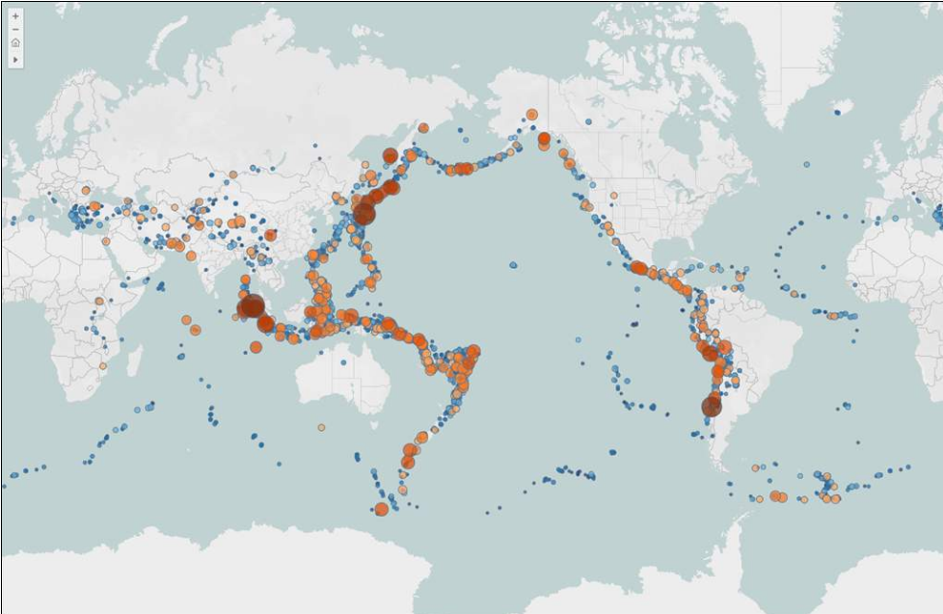

Symbol map data source requirements
To create a symbol map, be sure your data sources include the following types on information:
- Quantitative values
- Latitude and longitude coordinates or geographic locations recognized by Tableau
Symbol maps work best with data containing large variations of values. Without enough variation, the symbols will appear approximately the same size in the view.

Symbol maps building blocks
For a symbol map, use the following building blocks in the Tableau workspace:
Columns shelf | Longitude (continuous measure, longitude geographic role assigned)
Rows shelf | Latitude (continuous measure, latitude geographic role assigned)
Detail | One or more dimensions
Size | Measure (aggregated)
Mark type | Automatic

Filled maps
A filled map is ideal when you want to show ratio data.
- For example, if you wanted to see the percent of total podcast downloads across the United States, you could use a filled map to show trends spatially.

Filled maps data source requirements
To create a filled map, verify that your data source includes the following types of information:
- Quantitative or qualitative values
- Geographic locations recognized by tableau or custom polygons

Filled map building blocks
Columns shelf | Longitude (continuous measure, longitude geographic role assigned)
Rows shelf | Latitude (continuous measure, latitude geographic role assigned)
Detail | One or more geographic units (dimensions with geographic roles assigned)
Color | Measure or dimension
Mark type | Automatic or Map

Build a symbol map and edit locations
Use a symbol map when you want to show quantitative values for individual locations.
A typical symbol map can show one or two quantitative values per location, for example encoding the first value with size and encoding the second value with color.

Create a symbol map
To create a symbol map:
- Connect to a data source
- Switch to a new worksheet
- Drag a geocoded dimension (a dimension with a geographic role assignment), such as State, to the view. Tableau creates a map
- Set the Marks card to Circle, if tableau hasn’t already selected it
- Drag the first measure to Size on the Marks card
- Drag the second measure to Color on the Marks card
- As necessary, fine-tune the appearance of the marks, including their size, color, and opacity

You can fix ambiguous locations by specifying the Country/Region and/or State/Province for your data.

Build a filled map and use map tools
A filled map shows ratio or aggregated data in shapes known as polygons.
- The polygons can be countries, regions, states, or almost any area that can be geocoded in tableau (cities are an exception, which won’t allow for a filled area.)

Create a filled map
To create a filled map:
- Connect to a data source
- Switch to a new worksheet
- Drag a geocoded dimension, such as State, to the view. Tableau creates a map
- Drag additional geocoded dimensions, as necessary, to Detail on the Marks card
- Set the Marks card to Map, if tableau hasn’t already selected it
- Drag a measure to Color on the Marks card
- As necessary, fine-tune the appearance of the polygons, including their color palette and opacity
- Add any other details you wish to include. For example, add the state names to the map by dragging State to Label on the Marks card.

Consider color distribution
The distribution you specify for the color of the polygons – gradient vs. stepped, and the number of steps – highly affects how people interpret your data.
- To make the variation more apparent, reduce the number of visible color shades on the map.

Consider level of detail
The level of detail you specify in a filled map determines the patterns you want to see in the data.
- To simplify the pattern, aggregate up to a higher level of detail
- To make smaller trends more visible, aggregate down to a lower level of detail

Explore map data with the View toolbar
As you’re creating and using maps, get the most from them with the tools in the View toolbar, which become visible whenever the mouse pointer is over the map.

Create a Density Map
What is a density map?
Density maps allow anyone working with dense, overlapping data to easily make sense of the data’s concentration.
- This makes it easier to recognize spatial patterns in geographical data.

Introduction to density maps
A density map shows the frequency of marks in an area.
- By grouping overlapping marks, and color-coding them based on the amount of overlap, you can use tableau to create a density map to reveal trends in the mapped area.
Density maps use a color spectrum to show trends, such as foot traffic in a specific neighborhood or rent prices in a city.
- The changes in color and intensity indicate how the data varies within an area, making it easy to see where to focus your attention.
- You can gain different insights according to which variable you use of the density.

Data source requirements for a density map
The data source for a density map must be made up of latitude and longitude coordinates or locations names recognized by tableau.
Density maps are most effective when the location data is very precise, such as location coordinates in a limited space
- For example, events associated with the specific street-level addresses.
Additionally, density maps work best where the specific locations change continuously and smoothly across space, rather than values constrained to discrete locations such as district, borough, or neighborhood.

Density map building blocks
For a density map, use the following building block in the tableau workspace:
Columns shelf | Longitude (continuous dimension, longitude geographic role assigned)
Rows shelf | Latitude (continuous dimension, latitude geographic role assigned)
Detail | One or more fields with many underlying data points
Mark type | Density

A brief note about scatter plots
The density mark can be useful with scatter plots, too, especially if you’re more interested in the patterns than outliers.

Build a Density Map
Density maps help you identify locations with greater or fewer numbers of data points.

Create a density map
To create a density map:
- Connect to a data source with latitude and longitude coordinates (or location names recognized by tableau
- Switch to a new worksheet
- In the Data pane, double click the Latitude and Longitude fields to bring them to the view. Double clicking ensures that Tableau places the Latitude and Longitude fields in the correct locations: with Latitude on Rows and Longitude on Columns.
- Add distinct marks to the views by adding a dimension to Detail on the Marks card. This should be an informative dimension associated with the coordinates to tell a meaningful story. For example, use a dimension that will provide noticeable data concentrations in the areas referenced.
- If the data set has more than 10,000 items, you might see the warning below. Click Add all members.
- On the marks card, change the mark type to Density
Your basic density map is created, with the color, intensity, and other settings set to their defaults.

Adjust the appearance of a density map
By adjusting the default appearance of the density map, you can make trends in the density map more apparent.
- Different combinations of color, intensity, and mark size can reveal different patterns in the density data.
Adjust the color
Differences in color may be more or less apparent, depending on the color combination you select.
- Experiment with different colors to see which option brings out meaningful patterns in your data.
To adjust the color:
- Click Color on the Marks card
- From the Color menu, select one of the Density color palettes or any of the other existing color palettes

Adjust the intensity
By making adjustments to the intensity, you can change the way the density map represents the density levels.
- Experiment with both higher and lower intensity settings to see which brings out meaningful patterns in your data.
- Subtle changes to the intensity slider can result in dramatic changes in the map.
To adjust the intensity:
- Click Color on the Marks card
- Drag the Intensity slider to increase or decrease the vividness of the map

Adjust the size
Another setting you can modify as you seek meaningful patterns in your density maps is the size of the marks.
- By making the marks smaller or larger, you may be able to add a bit more detail to the patterns
To adjust the size:
- Click Size on the Marks card
- Drag slider to increase or decrease the size of the marks on the density map

Creating Relationships between Tables
What is a relationship?
We have some data from a bookshop, and we would like to know how the average ratings for our books compare to their sales.
We have books in one table, checkouts or sales in a second table, and ratings in a third table.
- We need to analyze this data that is spread out in different tables within one visualization
Relationships are a dynamic, flexible way to combine data from multiple tables for analysis.
- They are the default way to work with data from multiple tables in Tableau and are created directly on the Data Source canvas

Creating relationships
To relate three tables, we drag them out to the canvas one at a time.
- Tableau will automatically relate the tables if there is a common field name.
- We also see a preview of the data for that table in the data grid below the canvas
When you drag additional tables to the canvas, a line, also called a “noodle,” connects the two tables.
If a common field exists between the tables, tableau displays the connection information in the Edit Relationship dialog box and automatically creates the connection.
- You can change the relationship in this dialog box too, if needed.

View underlying data for the tables
Viewing data from the data source before or during analysis can be useful to give you a sense of the scope of each table, its field and their values, and general impressions about the data.

On the data source page
To verify the fields and data in each table, click the View Data icon to the right of each table in the list of sheets and tables.

In the Data pane of a worksheet
In a worksheet, the View Data icon is located at the top of the Data pane, below the data source list and to the right of the Search box.
Note that there is a separate tab for every table in the data source since relationships have been established between the tables, but they are not merged together into one big table.

How fields are displayed in the Data pane
Table name – are displayed in bold in the Data pane.
Dimensions – under each table, the dimensions for that table are listed first.
Measures – the measures for each table are displayed after the dimensions and a thin gray line.
Count fields – Tableau automatically generates a row count for each table at its native granularity.
Other automatically generated fields – directly below the tables and measures is a general area which contains the other automatically generated fields (such as Latitude and Longitude, if applicable)

Foler view
Use a folder view to show dimensions and measures in separate sections of the Data pane.
Select Group by Folder to display just the dimensions and measures, without the names of the related tables. Toggle back to the other view by selecting Group by Data Source Table.

Create relationships between tables based on a common field
To create a relationship between two tables, drag another table to the side of one that is already on the canvas.
- If there are common filed names, tableau recognizes them and creates the relationship.
If you have more than two or three tables, you may find it helpful to define and create a data model to show how the tables are related to match your business scenario.

Create a data model from a single data source

Create relationships between multiple data sources
You can connect to many data sources to build your relationships.
- If there is a common field name between the tables involved, then it doesn’t matter if those tables are located in one data source or in different data sources.

Use View Data to determine common field names
The first table that you drag to the canvas becomes the root table for the data model in your data source.
- After you drag out the root table, you can drag out additional tables in any order.

Relationships use correct aggregations with no data duplication
Tableau uses relationships to generate correct aggregations and build a query that uses appropriate joins during analysis, based on the current context of the fields in use in a worksheet
- The key is “current context.”

Joining Tables Using a Common Field
What is a table join?
There are many ways to combine data in Tableau.
- Relationships are the default method
- Joins are another method to combine data from multiple sources
- Other methods include blends and unions
The method you would choose would depend on your use case and scenario.
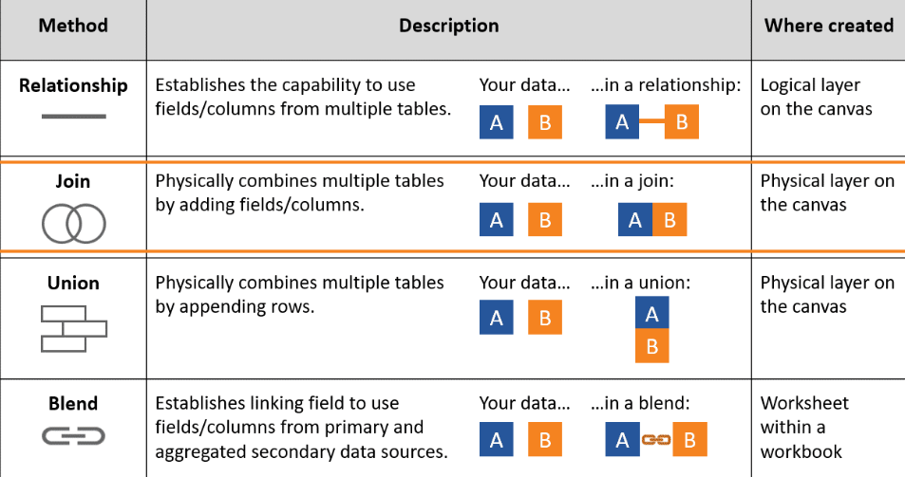

The purpose of Joins
As you analyze your data, you may discover that you do not have all the fields you need in order to answer your analytic questions.
You may want to combine your data with additional data sets.
- You can use a join to combine data based on common fields.
The result of combining data using a join is a table that’s typically extended horizontally by adding fields of data.

Different join types
Join types refer to the way the resulting tables are constructed.
- Changing the join logic between tables changes the results.
There are four types of joins we can do in Tableau: inner, left, right, and full outer.

INNER JOIN
- An inner join is the default join in tableau
- When you use an inner join to combine tables, the result is a table that contains values that have matches in both tables.
- When a value doesn’t match across both tables, it is dropped entirely.
LEFT JOIN
- When you use a left join to combine tables, the result is a table that contains all records from the left table and only records with matching values from the right table.
- When a value in the left table doesn’t have a corresponding match in the right table, you see a null value in the join results.
RIGHT JOIN
- When you use a right join to combine tables, the result is a table that contains all records from the right table and only records with matching values from the left table.
- When a value in the right table doesn’t have a corresponding match in the left table, you see a null value in the join results.
FULL OUTER JOIN
- When you use a full outer join to combine tables, the result is a table that contains all records from both tables.
- When a value from either table doesn’t have a match with the other table, you see a null value in the join results.
Note: With inner, left, and right joins, data loss can occur if fields are not present in all tables.

How to join tables
Even though relationships are the default method to combine data n Tableau, you can still use a join when you prefer.
- Joins are created in the physical layer of the Tableau data model
Join a table from the same data source
When you drag a table to the canvas, you are creating Tableau data model
The data model has two layers:
- The default view that you first see in the Data Source page canvas is the logical layer of the data source. You combine data in the logical layer using relationships (or noodles).
  - Think of this layer as the relationships canvas in the Data Source page.
- The next layer is the physical layer. You combine data between tables at the physical layer using joins (and unions).
  - Each logical table contains at least one physical table in this layer.
  - Think of the physical layer as the joins canvas in the Data Source
To create, view, or edit joins in Tableau, you must open the physical layer.
To open a logical table to see it in the physical layer, right-click or click the arrow on a logical table, and then click Open.
- Or, just double-click the table to open it.
Using Unions to Combine Data
Append data with unions
Tableau offers multiple methods to combine data
Unions are one way to combine information from multiple sources.
- In addition to unions, tableau provides other methods to combine data.
The table below shows a high-level comparison of the methods
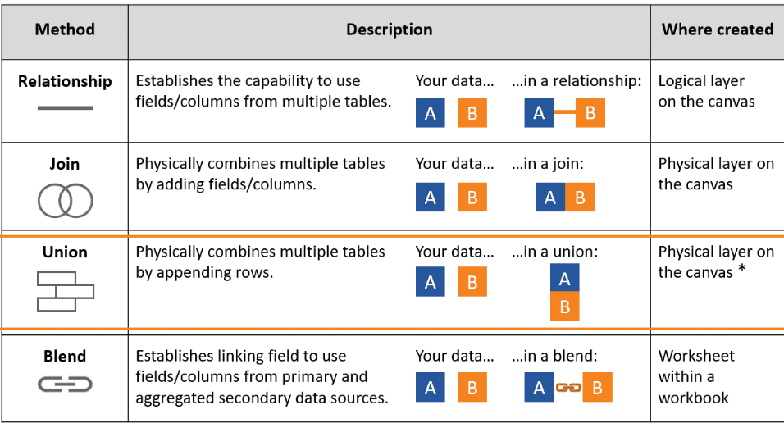
The method you would choose would depend on your use case and scenario.
Unions are the only method that “lengthen” the scope of your data by appending rows.
- The other methods, i.e., relationships, joins, and blends, have the effects of “widening” your data by adding fields or columns.

The purposes of a union
In tableau, you can use a union to combine data that has a similar structure so that rows from one table are appended to the rows of another table.
- For example, you might want to combine suppliers in one table, who have last names starting with A-M, with the suppliers in another table, who have last names starting with N-Z, so you have a complete list of suppliers in one table.
Unions are a way to combine your data by appending rows, thereby lengthening the scope of your data.
Resulting tables contain all the rows from all the tables, even the duplicate row.
- Values that don’t exist in the original tables are given null values in the results.

Two types of unions
In tableau, unions can be created manually or by using a wildcard search. Note that a wildcard search can be used to create a union only with tableau desktop.
Manual Union
- In a manual union, you select specific data sheets or tables to combine using a union.
- Tables in the union tables must come from within the same connection. That is, you cannot union tables from different databases.
Union using a wildcard search
- In a wildcard search, Tableau searches for files and automatically adds them to the union when their file names meet a naming convention criteria. A wildcard search helps when you expect new sheets or tables to be added to the data source in the future, like new months, quarters, or years of data.

Mismatched fields
Unions work best when the tables have a similar structure with matching field names and data types.
Mismatched fields occur when tables in a union have different names or data types.
- Mismatched fields are important to review and resolve as they can create unnecessary nulls in your data or you can end up with fields that you don’t need.

Different field structures
If there are fields that do not exist in one or more of the tables in a union, you may choose to keep the fields and the resulting null values or remove the fields.

Different field names
Some tables might contain fields that have the same data but have different field names.
- For example, one table might contain the field named Billing Rate, but another table might use the field name Bill Rate, resulting in a union containing both columns with some null values.
- In this scenario, you may want to merge the fields to ensure all of the related values align to one common field.

Create a Manual Union
Creating a union in Tableau
You can create unions in the canvas of the logical or the physical of the tableau data model.
There are two methods to create a union
- The drag and drop method and using the New Union option.
To add multiple sheets or tables to a union at the same time, press the control key, select the sheets you want to union, and then drag them all to the canvas.

Reference fields
In a union, Tableau adds reference fields to help you identify the source of the data.
- The number and names of these new columns will vary depending on the type of data source and type of union.

The New Union method
The other way to create a manual union is by using the New Union option.
This option is also an indicator that shows whether the type of data source you are connected to supports the creation of unions.
- If your data source supports unions, the New Union option displays in the left pane of the Data Source page after you connect to your data.

Edit or remove a union
After you have created a union, you can still edit it when necessary, for example, to change the sheets or tables in the union.

Remove a union
To remove a union, you need to remove the logical table that contains the union from the canvas.
To do this, click the down-arrow for the logical table and select Remove or drag the unioned table off of the canvas.
Note: if this was the first table you added to the canvas, referred to as the root table, all tables will be removed from the canvas.

Union and layers of the Tableau data mode;
Physical layer in the tableau data model
When you create a union in the canvas of the Data Source page, Tableau displays a logical table that is shown in the logical layer.
This logical table contains the unioned physical tables. To see the physical layer, select Open from the logical table drop-down menu that contains the unioned physical tables.
You can also create and edit unions in the physical layer of your tableau data source using the same drag and drop and New Union options as in the logical layer.

Representation of unions in Tableau layers
- In the logical layer, if a logical table contains more than one physical table using a union or a join, you will see an icon, for example, stacked bars for a union or a Venn diagram for a join. These icons alert you to the union or join behavior occurring in the physical layer.
- In the physical layer, a union is represented by stacked sheets underneath the first table name in the union.

Merge mismatched fields and analyze the unioned results
Identify and merge mismatched fields
When two field names in a union are mismatched, the unioned results will contain both fields, with null values in fields that did not exist in the original sheet or table.
You can merge the non-matching fields into a single field using the merge option to remove null values.
- When you use the merge option, the original fields are replaced by a new fields that displays the first non-null value for each row in the non-matching fields.

Blending Multiple Data Sources Using a Common Field
What is a data blend?
Imagine you are trying to analyze data from a cat rescue shelter and the data is contained in multiple data sources. How could you combine the information?

Tableau offers multiple methods to combine data
Relationships are the default method to combine data in Tableau.
Data blends are another way to combine information from multiple sources.
The table below shows a high-level comparison for the methods:
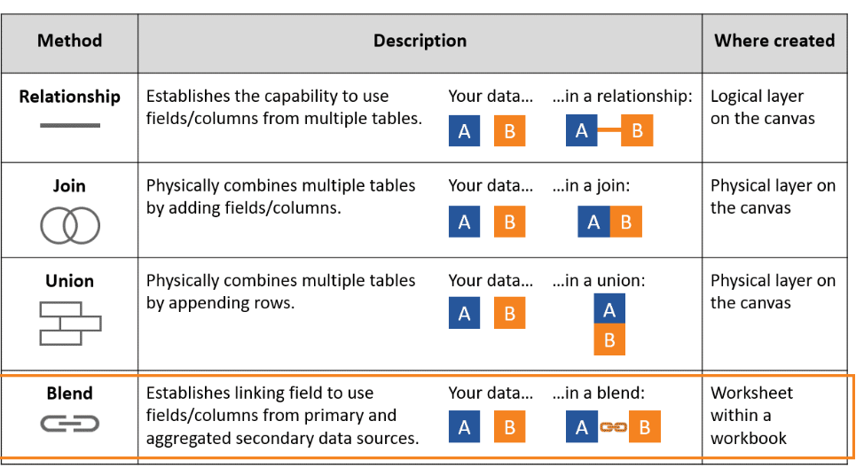

Data Blending
Data blending is using data from multiple sources in a single view.
It allows us to analyze related data from each data source.
It requires that the data sources share a common dimension.

Common use cases for data blends
Blends are most commonly used when combining data sources, including those with different levels of detail, in the following situations:
- You would like the specific linking fields or the number of linking fields to vary on a sheet-by-sheet basis.
- You want the primary data source to differ on a sheet-by-sheet basis
- You are using data sources, such as .json files and cube data, that cannot be combined with the default method of using a relationship.

Blend data in a view
Switch primary and secondary data sources
One advantage of blends is that you can have different primary and secondary data sources in different worksheets of the same workbook.

Ways to handle null values
- Creating a master list
- Filtering nulls
- Showing the nulls at the default position

Data blends expand your flexibility to combine data
Blends, unlike relationships or joins, never truly combine the data. Instead, blends query each data source independently, the results are aggregated to the appropriate level, then the results are presented visually together in a view.
- Because of this, blends can handle data sources that have different levels of detail, work with data source that don’t allow relationships or joins, and work with data sources that have already been published to tableau clouds or tableau server.

Data blends cannot be published
Blends are established individually on every sheet.
Because there is no true “blended data source,” only blended results from multiple data sources in a visualization, the blended data cannot be published to tableau cloud of tableau server.

Linking fields can be established manually
When a primary data source has been established by using a field in the view and the secondary data source is selected in the Data pane, any fields with the same name between the two data sources will display a link icon in the secondary data source.
- If the related field from the primary data source is used in the view, the link becomes active automatically.
- If the link appears “broken,” click on the icon to activate it.
If there are no link icons on the secondary data source, you may need to help tableau establish the link in one of two ways:
- If common dimensions don’t have the same name, for example, Region and Budget regions, renaming one will let Tableau identify them as common dimensions and establish the link.
- Alternatively, if you are using tableau desktop, you can manually define a relationship between the fields in the primary and secondary data sources by establishing the blend linking fields.
  - From the Data menu, select Edit Blend Relationships
  - Use a custom relationship to map the linking fields in the Blend Relationships dialog box

Building a Dashboard
What is the purpose of a dashboard?
A dashboard is a collection of several views, letting you view data simultaneously to get richer insight.
- For example, if you have a set of views that you review every day, you can create a dashboard that displays all the views at once, rather than navigate to separate worksheets.
The main purpose of a dashboard is to explore relationships in data
Similar to worksheets, you access and create dashboards from tabs at the bottom of a workbook.
Dashboards are used to monitor, explore, and inform the end user.
- Monitoring can give quick insight on status
- Exploration dashboards help users answer their own questions
- Informative dashboards help user see and understand the data quickly
When you modify a sheet, any dashboards containing it change, and vice versa.
- This is because data in sheets and dashboards is connected.
- With a live connection, both sheets and dashboards update with the latest available data from the data source.
- This interaction is important to remember when configuring the views in your dashboard
Note: Without a live connection, the sheets and data sets will only update with the latest data when the refresh occurs.

Plan for a successful dashboard
A well-designed dashboard can align your organization’s efforts, help uncover key insights, and speed up decision making.
The following dashboard example provides an executive overview of sales by segment and category.
- It breaks down sales and profit, and offers a convenient map to view regional performance.
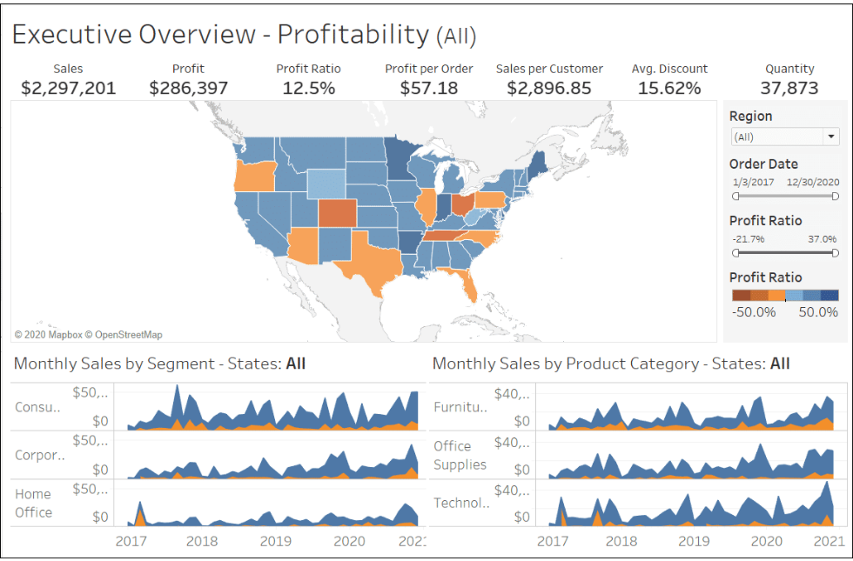
This is a great dashboard. But before you build one like this, you need to create a plan for it, keeping a few important things in mind.

Considerations for planning a dashboard
Who is your audience?
- Knowing and understanding the audience for your dashboard will influence both the content you include and how you present it.
- Your intended audience will help you to determine which chart types to use, how you arrange the charts on the dashboard, the level of detail you provide, and the level of interaction you build in.
What information is important to your audience>
- When including data in a dashboard, consider what the key takeaways are for your audience.
- Make sure that you dashboard is simple and only includes relevant information, leads with the most important data, provides interactivity so that users can find their own answers and insights, and uses consistent design, language, and color scheme.
Why are you creating a dashboard?
- The best visualizations have a clear purpose and work for their intended audience.
- Are you presenting a conclusion or a key question?
- Is it to inform your users?
- Is it to explore the data? Understanding the purpose od a dashboard is crucial in knowing what information to include, and what to exclude.
Where is the dashboard going to be viewed?
- Are users going to view the dashboard on different size devices, such as a desktop, laptop, tablet, and phone?
- If the dashboard will be used on a small device, consider what device-specific composition and content changes will be needed.
- The more you customize the dashboard to the viewing device, the more you will enhance users’ experience.
- Will users want to print a dashboard, for example, as a pdf to take to a meeting or look at offline?
- Depending on the audience and purpose, consider which charts or elements need to be interactive, and which could be static.

Combine your views in a dashboard
Add views to a dashboard
You create a dashboard in much the same way you create a new worksheet
- At the bottom of the workbook, click the New Dashboard icon and update with the most recent data from the data source.
- To add views from any worksheet in the workbook, find the title of the worksheet you want to use in the Sheets list and drag it to the canvas.
- To replace one worksheet on a dashboard with another, select the worksheet in the dashboard view, then in the Sheets list, hover over the title of the worksheet you would like to use instead and click the Swap Sheets icon.
- From the dashboard, you can return to a worksheet in one of the following three ways
  - Click the Go To Sheet button in the Sheets list
  - Click the tab at the bottom of the workbook to switch to the view
  - From the view’s toolbar, click the Go to Sheet button that appears in the view’s toolbar after selecting the view in the dashboard.

Dashboard settings
After adding sheets to a dashboard, you can customize the dashboard further for its appearance and usability.
You can use the settings in the Dashboard and Layout panes to customize your dashboard.

Hide and unhide sheets
Sometimes you may want to hide your sheets in your workbook, so that only the dashboard tab is visible.
- This is a way of simplifying the workbook to make it easier to use.
- It’s practically helpful if you have several dashboards and a dozen or more sheets in one workbook.
To hide a sheet:
- On the Dashboard pane, under Sheets, right-click the sheet, and select Hide.
- To unhide the sheet, right click the sheet under Sheets in the left pane and turn off the Hide option.
  - You can also hide sheets by right clicking the tabs.
- If you want to hide all sheets, right click the dashboard tab, and click Hide All Sheets. To make them visible again, right click and select Unhide All Sheets.

Show/Hide button lets you toggle the visibility of floating containers
Show/hide buttons can be particularly helpful when you want to temporarily hide groups of filters to reveal more of a visualization.

It’s possible to reorder floating objects on a dashboard
The Item Hierarchy area on the Layout pane shows the relationships between objects on your dashboard.
- Drag floating items in the hierarchy to change how they layer over each other.
- Items at the top of the list appear in the front, while items at the bottom appear at the back.

You can evenly distribute a layout container’s items
With the layout container selected, choose Distribute Contents Evenly from its short cut menu.

Highlight and filter data in dashboards
A well-designed dashboard layout should enable you audience to understand key points at a glance. However, what if the data is complex, or doesn’t lend itself to instant interpretation?
Tableau provides many interactive features in dashboards that allow users to explore a dashboard and ask questions of the data.
The most common interactive features are highlighting and filtering.

Legend highlighting
You can use highlights to call attention to marks of interest and enable users to explore your dashboard further.
- For example, you can manually select the marks you want to highlight and use the legend to select related marks.

Filtering
Filters allow a user to visually isolate subsets of the data.
Filters can be applied to individual worksheets in a dashboard or to all sheets in a dashboard.
- For example, in a view showing the sales prices of houses, when you select a particular house, a filter can show details of the house in a different view.

Add highlights and filters in a dashboard

Creating Interactive Dashboards Using Actions
Types of actions
Actions are a feature of dashboards that allow users to interact directly with the data in the view and access related web-based content.
Actions require a source sheet, where the user interacts to run the action.
- Some actions also use a target sheet, where the results of the action are displayed
There are several types of dashboard actions in Tableau.

Filter action
Filer actions help guide analysis by using the data from one view to filter data in another.
Typically, a filter action sends information from a selected mark to another sheet showing related information.
- Behind the scenes, filter actions send data values from the relevant source fields as filters to the target sheet.

Highlight action
Highlight actions allow you to call attention to marks of interest by retaining color for specific marks and dimming all others.
You can highlight marks in the view using a variety of methods.
- For example, you can manually select the marks you want to highlight, use the legend to select related marks, use the highlighter to search for marks in context, or create an advanced highlight action.

Go to Sheet action
Go to Sheet actions simplify navigation to other worksheets, dashboards, or stories.

Go to URL action
URL actions create hyperlinks to external resources, such as a web page, email link, or a file.

Parameter and set actions
Parameter actions let your audience change a parameter value through direct interaction with a viz, such as clicking or selecting a mark.
Set actions let users change the values in a set by directly interacting with marks on a viz.

Methods for running an action
Depending on how the action is created, you can run an action using one of the following three methods:
Hover:
Rest the mouse over a mark in the view to run the action. The hover option works well for highlight actions.

Select:
Click a mark in the view to run the action.
This option works well for most types of actions.
- However, the select method is considered less favorable for URL actions because it’s not a good practice to redirect users to another site in a single click.

Menu:
Click a selected mark in the view and then select an option on the tooltip.
The menu option is a best practice to direct users to external URLs

Add actions to a dashboard
Filter action
The filter action is the most commonly used action on a dashboard.
A filter action gives added control to users, enabling drill-down capability between views.

Highlight Action
Highlight actions are used to call attention relevant data by retaining color for some marks while dimming all the others.

Go to Sheet action
The Go to Sheet action allows users to go from one dashboard to another sheet or dashboard.
To create a Go to Sheet action:
- From a dashboard, select Dashboard and then click Actions
- In the Actions dialog box, click Add Action and then select Go to Sheet.
- In the Add Sheet Navigation Action dialog box, perform the following actions:
  - Enter a name for the action
  - Specify the source sheet
  - Specify a run method
  - Specify the target sheet

Go to URL action
URL actions allow end users to connect web-based resources, and these can be dynamically programmed to update based on the user’s selection.
To create a Go to URL action:
- From a dashboard select Dashboard and then slick Actions
- In the Actions dialog box, click Add Action and then Go to URL
- In the Add URL Action dialog box, enter a name for the action.
  - To enter field variables in the name, click the arrow to the right of the Name box.
- Use the drop-down list to select a Source Sheet or data source
  - If you select a data source or dashboard you can select individual sheets within it
- Select how users will Run the action
- Specify a URL, with an ftp, http, or https prefix
- To enter a field and filter values as parameters in the URL, click the arrow to the right of the URL box
  - Be aware that any referenced fields must be present in the view, not just a related data source
  - You can also create a link to an email using the Go to URL action.
    - Just type mailto: and click the arrow button to select the field in your data that contains the emails addresses

Refine a Dashboard
Refine for placement and layout
As you create your dashboard, you’ll want to ensure that the sheets and other elements are sized and positioned correctly.
Start with the layout
Select worksheets to include
- Decide which worksheets you want to include in you dashboard and make sure that each worksheet you want to use has a title.
- You don’t have to show the title, but it’s easier to select the correct worksheet when it has a meaningful name.
- Make sure that the view with your key finding or main question is placed in the most prominent spot.
- Note: You can easily see a list of where a worksheet is being used within the workbook by right clicking the worksheet tab and selecting Used in.

Set layout orientation with containers
- Layout containers allow you to set the orientation of the items in your dashboard.
  - A horizontal layout container resizes the width of the views and objects it contains
  - A vertical layout container adjusts height
- When you drag worksheets into a dashboard, the size and layout are typically fixed by default.
  - Use layout to create a definition within your dashboard and then fine tune the placement and position of the worksheets
- Be aware that items within the same layout container can resize and change position when users interact with the dashboard.
  - These changes help minimize extra white space within the container

Use non-worksheet objects
- You can use non-worksheet objects to further customize your dashboard
Item | Description
Text | Use for instructions, notes, or other helpful descriptions.
Image | Insert images. Good for company and organization logos or other images.
Web Page | Insert a URL and display a web page in your dashboard.
Navigation | Add a button that navigates to another dashboard or sheet.
Extension | Insert a dashboard extension.
Export | Add a button to allow dashboard consumers to export the dashboard  according to the export type you determine (PDF, PowerPoint, or Image).

Consider floating a view
- To save space or improve its proximity to another item, you can float a view, filter, legend, text, image, web page, or even a layout container.
  - For example, you have grouped a set of key performance indicators into a container. By floating that container, you can save space by strategically layering the floating container over an appropriate location on the dashboard.
- You can also add a button object to floating containers (vertical or horizontal) that will enable you to toggle between showing and hiding them.
  - This feature enables you to save space when dashboard elements (filters, legends, views, and so on) do not need to be visible at all times.

Add white space
- White space helps to align and separate objects.
- Add white space using one of the following methods.
  - Insert and resize a blank container
  - Adjust either the outer or inner padding of a view, container, or object.
- Padding lets you precisely space items on a dashboard, while boarders and background colors let you visually highlight them.
- Inner Padding sets the spacing between item contents and the perimeter of the border and background color; Outer Padding provides additional spacing beyond the border and background color.

Use borders and background colors sparingly
- It is easy to add too many visual elements, which in turn will distract rather than enhance the dashboard experience.

Determine the device layout (Tableau Desktop Only)
After you have built a dashboard, you can create layouts that are specific to particular devices. Dashboards can include layouts for different types of devices that span a wide range of screen sizes. When you publish these layouts to Tableau Server or Tableau Cloud, people viewing your dashboard experience a design optimized for their phone, tablet, or desktop. As the author, you only have to create a single dashboard and deliver a single URL.

Refine for instructional clarity
How do you help your audience so they can immediately understand the purpose of your dashboard and how to use it?
Careful use of instructional text and titles gives your users instant directions on how to use the dashboard.

Instruction and annotations
Adding instructions to your dashboard enhances and guides the user experience, especially when you want users to interact with your view.
Here are some tips for adding instructions:
Use titles on filters in the view to provide direction to users.
- All filters have titles you can edit using the drop-down menu on the filter.
- For example, rename a Region filter to “Select a Region”
Add text boxes with instructions on how to read the elements in your dashboard, especially if you are sharing data that is not familiar to your audience.
Use a common font color, size, and style for all instruction text.
Use annotations to call attention to interesting data points, but sparingly. Edit the default annotation text so it reads well.

Improve appearance and readability
There are many simple changes you can apply to dashboards that dramatically improve their appearance and readability
Assess you dashboard carefully.
Does the data stand out clearly on its own?
Is the dashboard too busy, with too many marks and details?

Color, sizing, and fonts
Use of appropriate colors, sizing, and fonts are one of the simplest and basic changes that you can make to improve the usability of any dashboard.
These aspects form the visual foundation of your dashboard.
Color
- Limit total number of colors used
- Reserve brightest colors (or any color) for the most relevant data points.
- Using two shades of the same hue (such as light blue and dark blue), suggests a relationship, especially if you are using other colors as well. If you don’t want to associate those two items, assign them different colors
- Consider carefully whether adding borders or background colors helps focus attention or increases the visual clutter.

Sizing
- Keep your users’ screen size in mind
- When using crosstabs, don’t use Fit Entire View; use a combination of a scroll bar and either Fit Width or Fit Height.
- To resize elements, try shift+ drag. (For example, use this if you have a 4 -quadrant dashboard and want to resize the bottom-left quadrant without resizing the upper-right quadrant.)
- When resizing individual worksheets, use CTRL and the arrow keys to resize rather than manually dragging.

Font
- Make the fonts readable and sized appropriately.
- Use fonts that optimize online readability.
- Make the font consistent as much as possible.
- The quickest way to make a fast, large-scale change to all the titles in your dashboard is to change them at the workbook level. A workbook is the largest possible container for formatting settings
  - Click Format, and then select Workbook.
  - Make you changes under Fonts, in the Format Workbook pane.

Tooltips
Once you are done with the main design work, review your tooltips.
Tooltips reinforce the story you’re trying to tell with your dashboard.
They also add helpful context to your view.
Tableau populates a view’s tooltip automatically, but you can easily customize them by clicking Worksheet > Tooltip.
Just like how you want to put your most important views in the upper left of your dashboard, you want the most important elements of your tooltip to be at the top.

Grid lines and shading
It’s a good practice to remove unnecessary grid lines or shading within views, which van be distracting for your user.
Use the Format option to easily remove unnecessary grid lines and shading:
- Select the worksheet that uses the grid lines, click the Format menu, and then select ‘Lines to remove grid line from the rows in the worksheet.’
- To remove shading from a worksheet, sue the Format menu, and select Shading.

Add visualizations in tooltips
As you create views and look for ways to reveal more details about data to your audience, consider using a view in the tooltip to give the user more information without cluttering the dashboard.
Showing related vizzes in tooltips helps your users engage with the data at a different or deeper level, while keeping them in the current context and maximizing the space available for the current view.

Add a viz in tooltip
To place a viz in a tooltip:
- From the main (source) viz, click Tooltip on the Marks card
- Click Insert, and then select Sheets
- Select the target sheet that should appear in the tooltip, and click OK
  - Now when you hover over a mark on the source viz, the tooltip displays the target viz

Did you know?
You can set the size of a view in a tooltip
The view in the tooltip is always static
It’s possible to format tooltip text
Hovering on a mark, filters the target viz
Show Me resets the tooltip

Add and format animations in a visualization
Tableau viz animations allow you to present changes in data.
You can animate visualizations to better highlight changing patterns in your data and direct your audience’s focus to what matters the most.
Without animations, changing something like a date filter causes scatterplot marks to suddenly jump to new locations.
It’s difficult to pinpoint what changed or why, but a smooth animation connects the dots.
You can spot and understand changes, such as when a specific mark becomes an outlier, when there’s a sudden value spike or dip, or when data clusters appear.

Types of animations
Simultaneous
- The defaults simultaneous animations are faster and work well when showing value changes in simpler charts and dashboards.
Sequential
- Sequential animations take more time but make complex changes clearer by presenting them step-by-step.

Authoring animations
Animations can be configured for entire workbooks down to individual sheets.
This is especially useful when applying different settings to multiple vizzes in one dashboard.
To create an animation:
- Form the menu, select Format, and then click Animations
- If you want to animate every sheet, under Workbook Default, click On. The do the following:
  - For Duration, select a preset, or specify a custom duration of up to 10 seconds.
  - For Style, select Simultaneous to play all animations at once, or Sequential to fade out marks, move and sort them, and then fade them in.
- To override workbook defaults for a particular sheet, change the settings under Selected Sheet.

Tableau allows you to animate a broad variety of vizzes.
Once on, viz animations automatically work for any underlying data changes.
However, the following Tableau features don’t animate:
- Maps, polygons, and density marks in web browsers
- Pi and text marks
- Axes and headers
- Forecasts, trends, and reference lines
- Page history (if a viz includes these, turn off animations to avoid unexpected behavior.)

Telling Stories with Data
Introduction to Tableau Stories
A story is a sheet that contains a sequence of views and dashboards that work together to convey information.
You can use stories to make a compelling case by showing how analytical insights are connected.
Since a story is a sheet, the methods you use to create, name, and manage worksheets and dashboards also apply to stories.
- Each individual sheet in a story is called a story point.
When you share a story – for example, by publishing a workbook to Tableau Public, Tableau Server, or Tableau Cloud – users can interact with the story to reveal new findings or interact with data.
You can create stories to tell a data narrative, provide context, and demonstrate how decisions relate to outcomes, or simply make a compelling business case.

Best practices for telling great stories
A good data story brings data and discoveries to life.
Use the following best practices when creating a story:
Know the story’s purpose
- Before you build your story, take some time to think about the purpose and what you want your viewers’ journey to be.
  - Is it a call to action, is it a simple narrative, or are you presenting a business case?
- If you’re presenting a case decide whether you want to present data points that lead up to a conclusion at the end, or start with a conclusion, and then show the supporting data points. The latter approach works well for a bust audience.
- Finally, sketching out your story first on paper or a whiteboard can help you quickly identify problems with your sequence.
Keep it simple
- A common error is trying to cram too many views and dashboards into a single story. The result is too many points for your viewers to take in. The clarity of each story point is also important.
- Take a step back and consider your story from the perspective of someone who’s never seen it. Every element should serve a purpose. If captions, titles, legends, or grid lines aren’t necessary, get rid of them!
Plan for fast load times
- The most wonderful story wont have much impact if it takes too long to load.
- People find long waits frustrating.
- Some of the most critical performance decisions you make begin before you even create your first view or story, in the data preparation stage.
Use ‘Fit to’ in your dashboards
- Dashboards are a common ingredient in Tableau stories. For dashboards that you plan to include in your story, use the Fit to option under Size on the Dashboard pane. It will resize your dashboard so that it’s the right size for the story you’re creating.

Steps in creating a story
As you learned previously, stories show how facts are connected, and how decisions relate to outcomes.
When you create a story, each story point can be based on a different view or dashboard, or the entire story can be based on the same visualization seen at different stages.
You can publish your story to the web, or present it to an audience.
When creating a story, use the following sequence of steps:
- State the question
  - A successful story is well-framed, meaning its purpose is clear. Story titles are in view at all times because they're a handy way to keep your story's purpose front and center. By default, Tableau uses the worksheet name as the story title.
- Start with the big picture
  - To help orient your audience, the first story point you create should show the broadest possible viewpoint.
- Drill down
  - Just like a good novel moves the action along, so does a good data story. Starting with your next story point, you'll use the drill-down technique in order to narrow down the scope of the story and keep the narrative moving.
- Highlight outliers
  - Once you start drilling down, further engage your audience by examining data points at the far end of the scale.
- Show a trend
  - Show you audience a trend you spotted when you were initially creating views and dashboards
- Offer your analysis
  - Explain your viewpoint of what the analysis data is showing
- Answer the question
  - Finally, answer the question that you started with. Also be transparent about all your assumptions, omissions, nuances, and limitations when drawing conclusions from data.

Create a story
Story workspace
As you work on your story, you can use the following controls, elements, and features
Story pane
- Use this pane to drag dashboards, sheets, and text descriptions to your story sheet. This is also where you set the size of your story and display or hide the title.

